Data Science and Phyton

Tyrik Edwards

Bowie State University

Symbolic Computation using Big Data

CTEC 298

Spring 2021

**Introduction**

Data science is a between disciplinary field that utilizes logical strategies, cycles, calculations, and frameworks to remove information and experiences from organized and unstructured information and apply information and noteworthy bits of knowledge from information across an expansive scope of use spaces. Through CTEC 128 and 298 we investigate information science and the devices utilized for it. In this paper we talk about the devices utilized in CTEC 128 and the new devices we learned through CTEC 298 which incorporates utilizing python and its libraries to make plots to grandstand information.

**Summary of CTEC 128 Paper**

For CTEC 128 we were working on a project regarding police stops in Stockton, California. While checking out the dataset it was a great deal to measure, and we needed to figure what factors to see that will assist us with addressing our inquiries. In the dataset, it showed the official ID and the individual that was halted their age, race, and sex and why they were halted. It likewise showed in case they were captured or not. We decided to complete 2 urban communities in California since it is the most populated and various state. Likewise, it had most of the information than all the other datasets and we did an examination of the littlest and most elevated populated urban communities in the state which is Stockton, having a populace of 291,707 and San Diego having a populace of 1,307,402. We picked 8 factors to take a gander at inside the dataset, which was age, sex, race, cautioning gave, reference gave, capture and justification for the stop. We needed to switch our factors up at first on the grounds that initially, we were going to a sum of 4 urban areas in California yet slice it down to Stockton and San Diego. Our last information factors just comprised of the information we required, the factors the two urban communities partook in like manner, and what planned to assist us with addressing our exploration questions. We utilized external sources to assist with giving us better insights and realities to help better stress on our information.

**CTEC 298 Material Submitted**

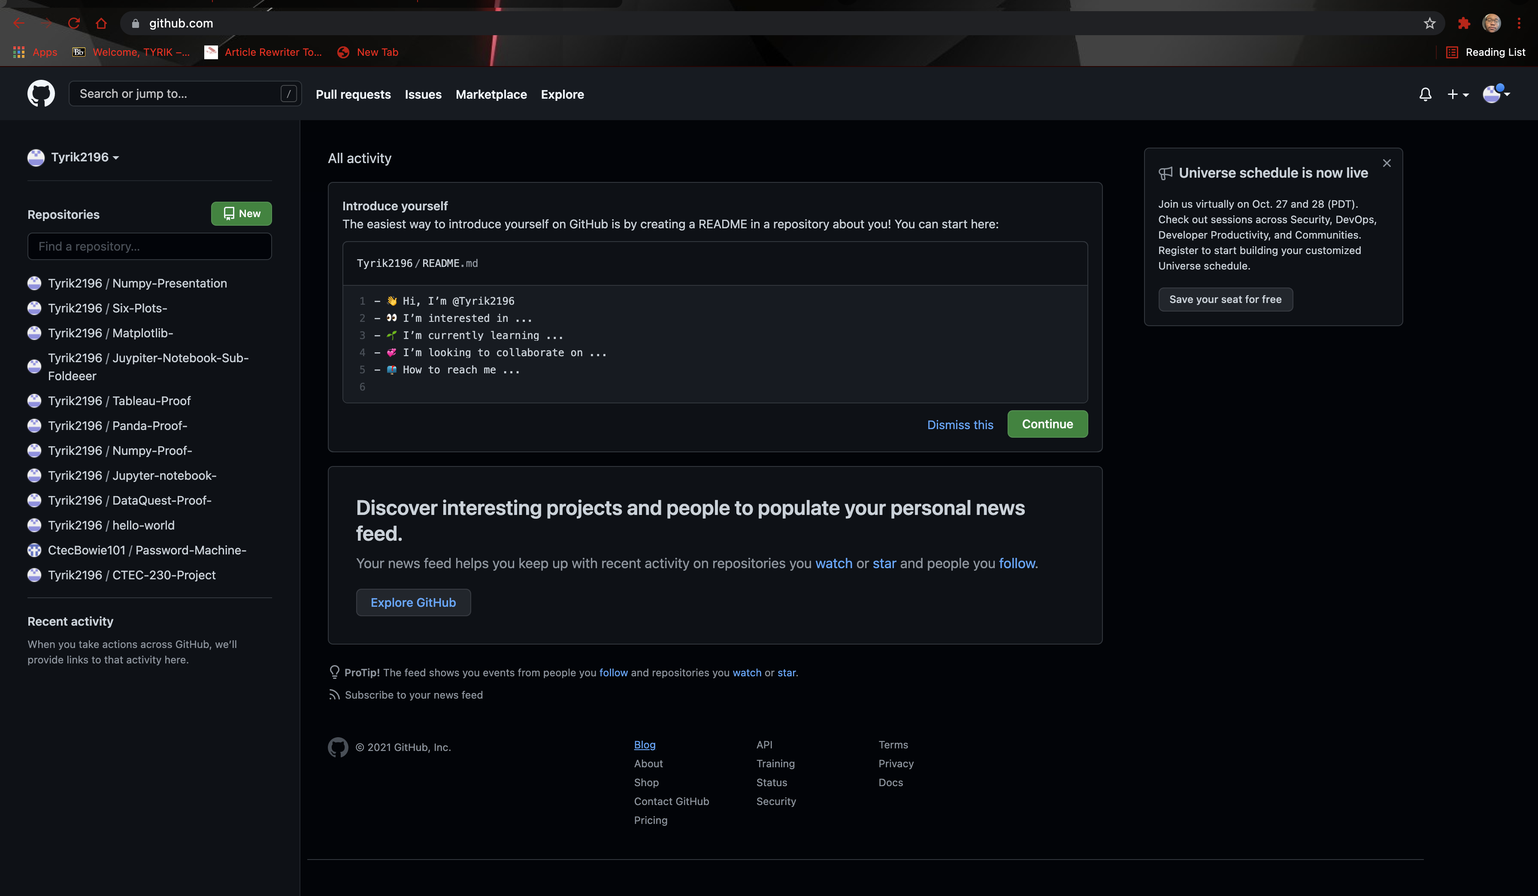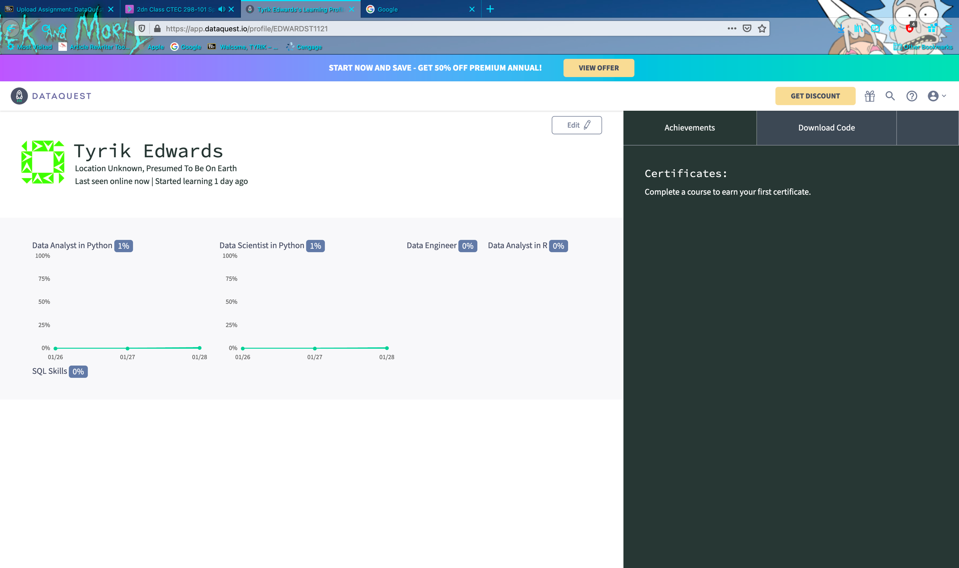



This picture shows some of the CTEC 298 material that was submitted. This picture likewise shows the GitHub archive that was utilized to house these records to be seen freely. In CTEC 298 we covered Python and its different libraries to plot diagrams/charts. We initially began the semester finishing Dataquest Tutorials so we can turn out to be more acquainted with Python. After finishing those we worked on finishing instructional exercises on Matplotlib, NumPy, and Pandas. These are the 3 instruments inside Python that we used to finish our tasks. Matplotlib, NumPy, and pandas were completely used to make the six plots that will be shown later in this paper. We likewise found out with regards to Tableau, which is utilized to make visuals with Excel information.

**Import Of Data**

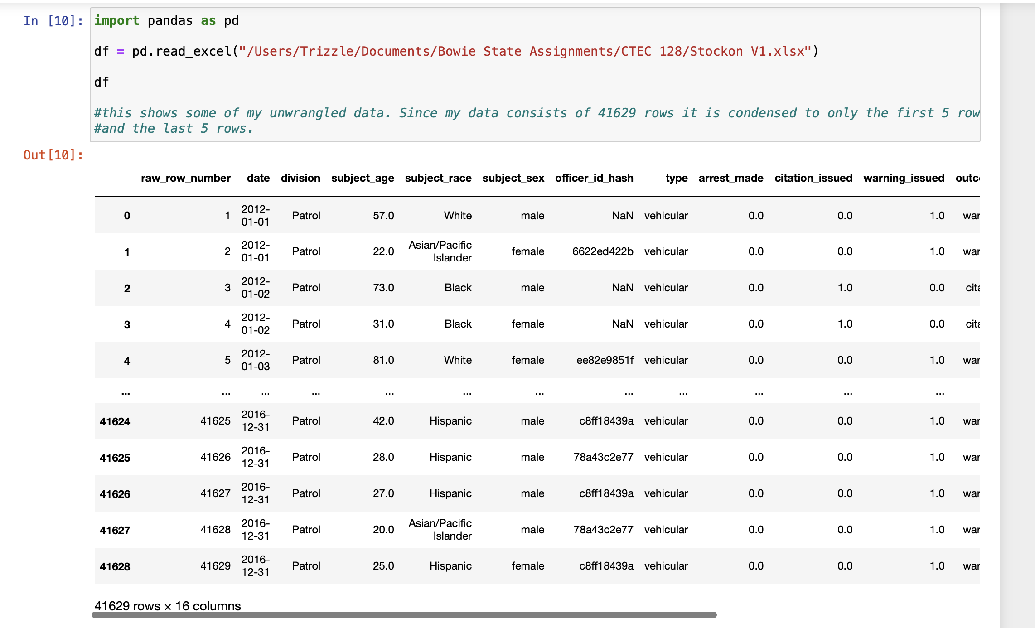

First, I imported the data, to import the dataset we use the read_excel () function of pandas and store it in the Data Frame named as data. As the dataset is in tabular format, when working with tabular data in Pandas it will be automatically converted in a Data Frame. Data Frame is a two-dimensional, mutable data structure in Python. It is a combination of rows and columns like an excel sheet.

The head () function is a built-in function in pandas for the data frame used to display the rows of the dataset. We can specify the number of rows by giving the number within the parenthesis. By default, it displays the first five rows of the dataset. If we want to see the last five rows of the dataset, we use the tail () function of the data frame like this:

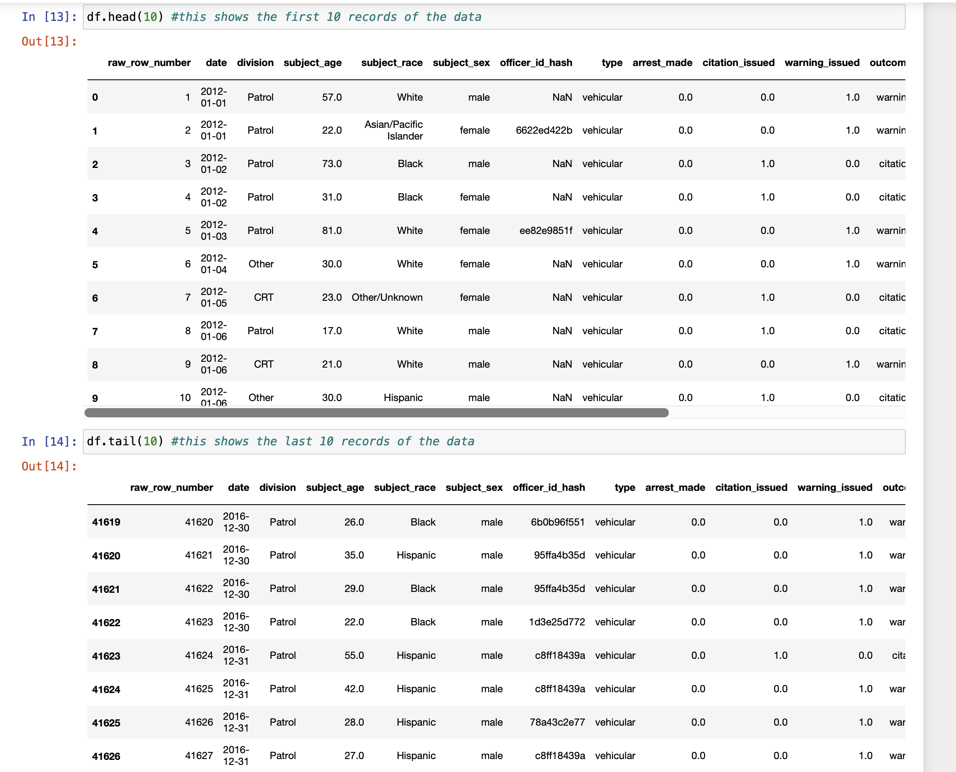

There are no null values present in our dataset. But if there are any null value s preset, we can fill those places with any other value using the fillna () function of Data Frame. Following is the syntax of fill na () function. This function will fill NA/NaN or 0 values in place of null spaces.

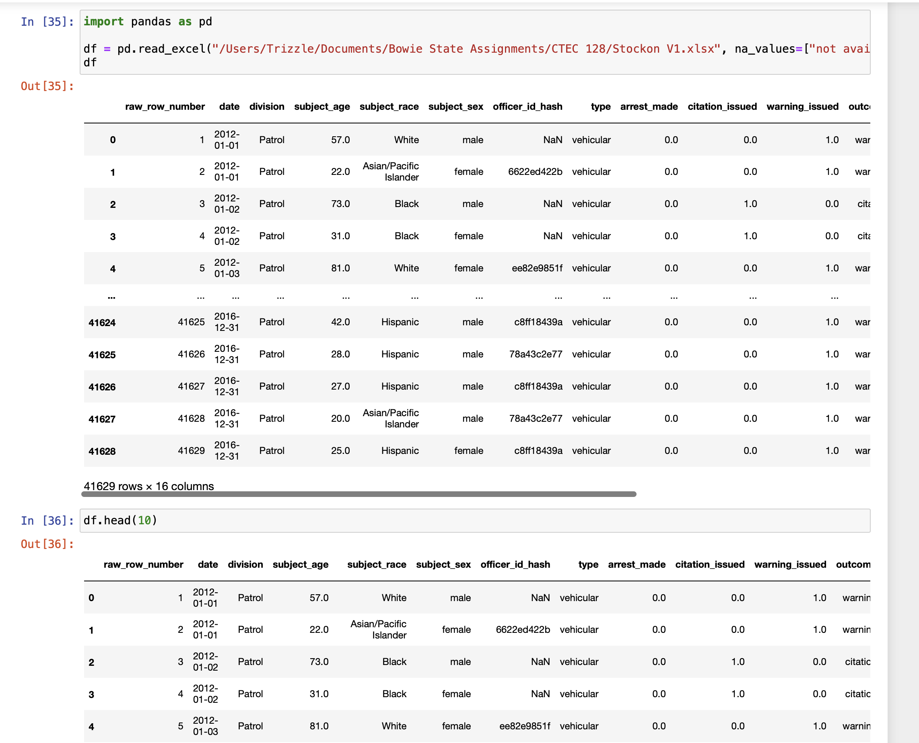

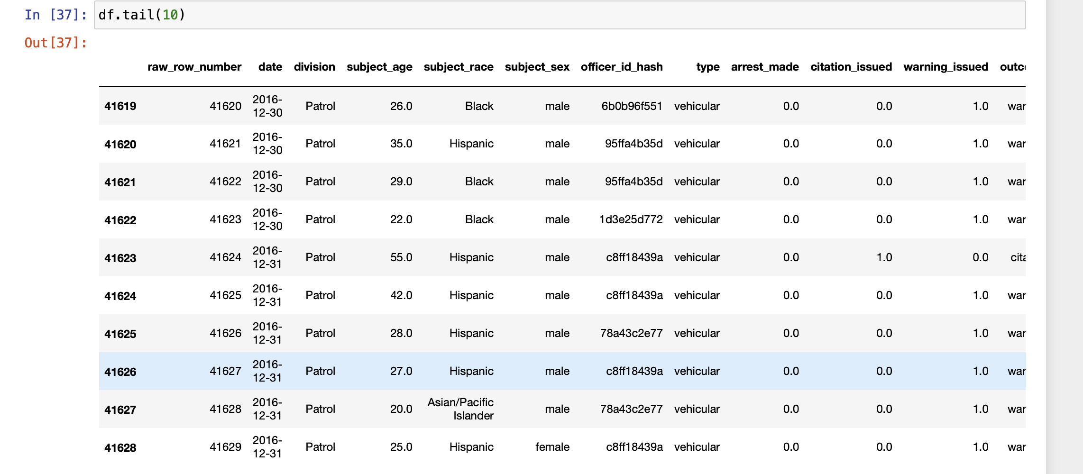

Plot/Visualization Deliverables

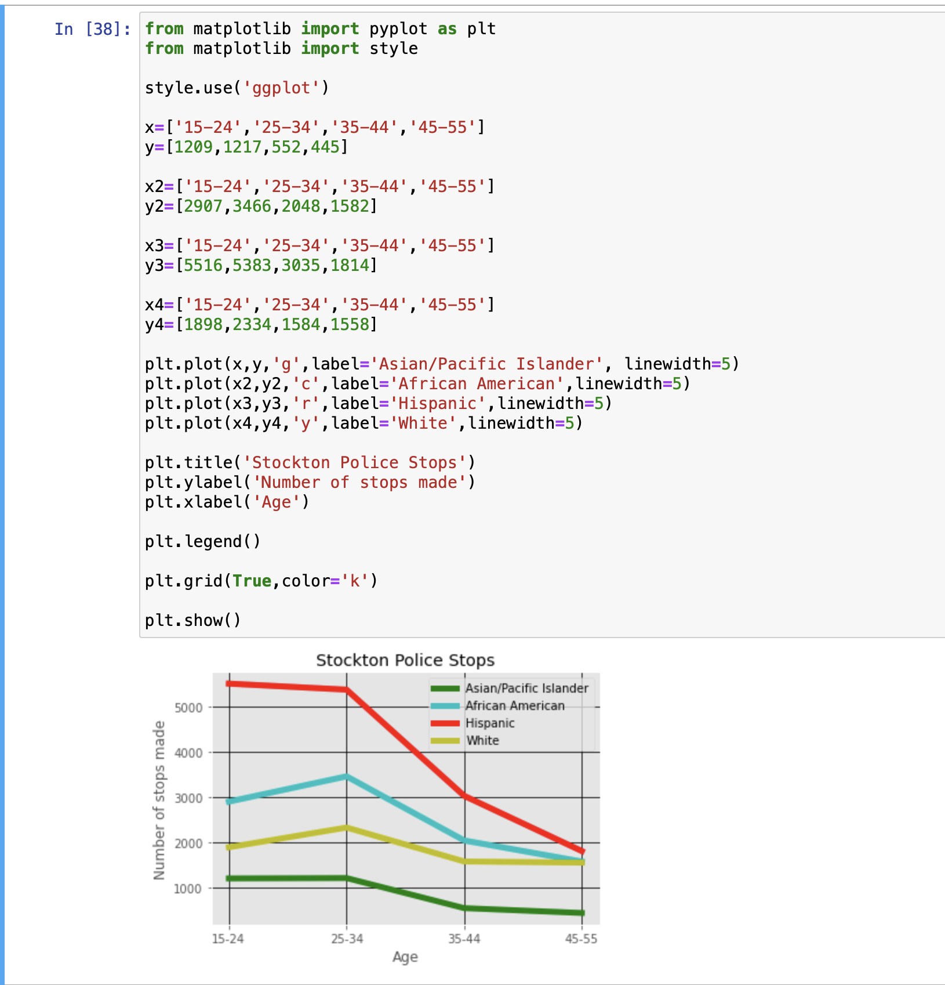

A line graph is a sort of graph used to show data that changes over the long haul. plot line utilizing a few focuses associated by straight lines. We additionally consider it a line diagram. The line diagram involves two axes known as 'x' axis and 'y' axis. In this case the x axis shows the age range of the citizens that were pulled out and the y axis shows the number of times they were pulled over. I did 4 different colored lines to represent the race of the citizens and as you can police stops happened more in the younger age range.

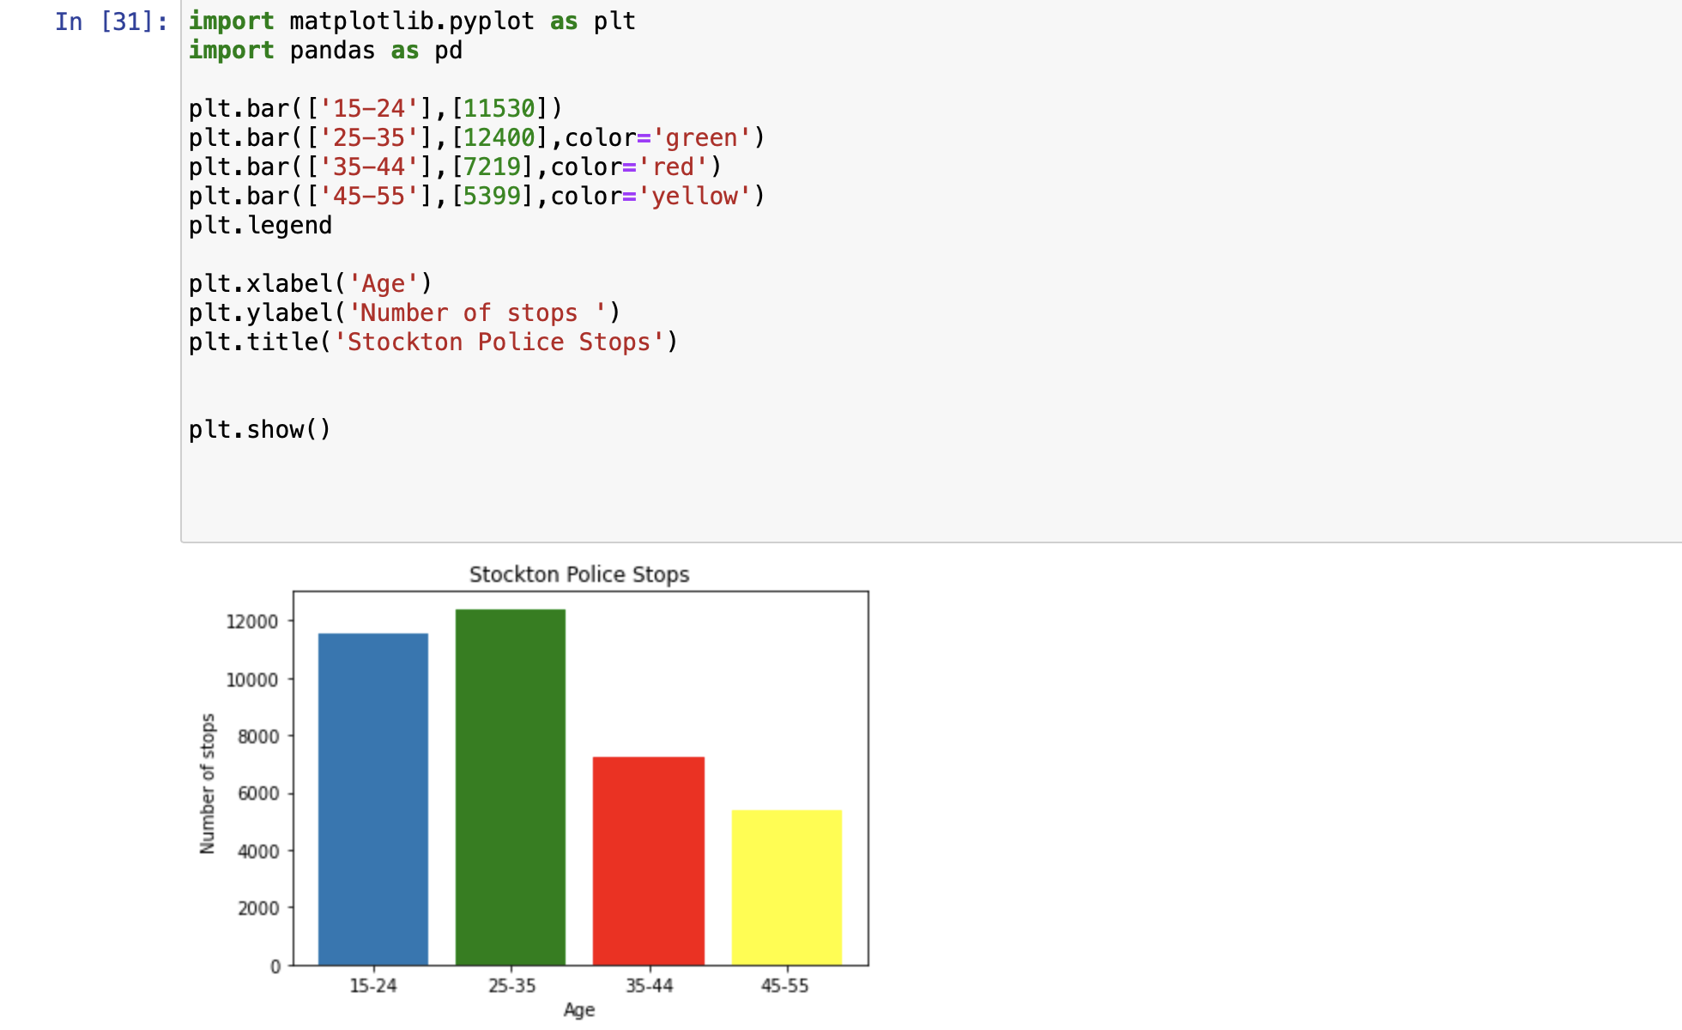

In this bar graph the x axis shows the age range and the y axis shows the number of police stops. Unlike the line graph the only thing being compared is the age range. 25 – 35 were pulled over more than any other group.

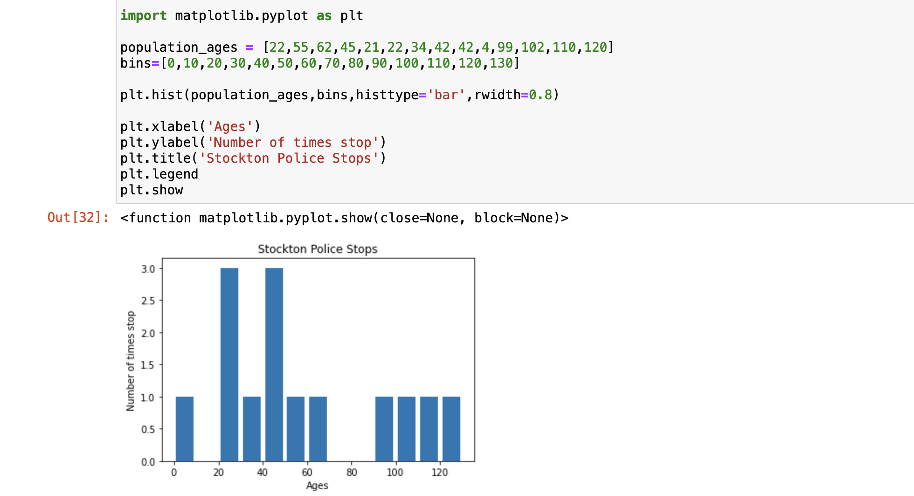

In the histogram different ages are displayed for the x-axis and the y axis is the number of stops. Majority of the plots are comparing the same thing except for the pie graph.

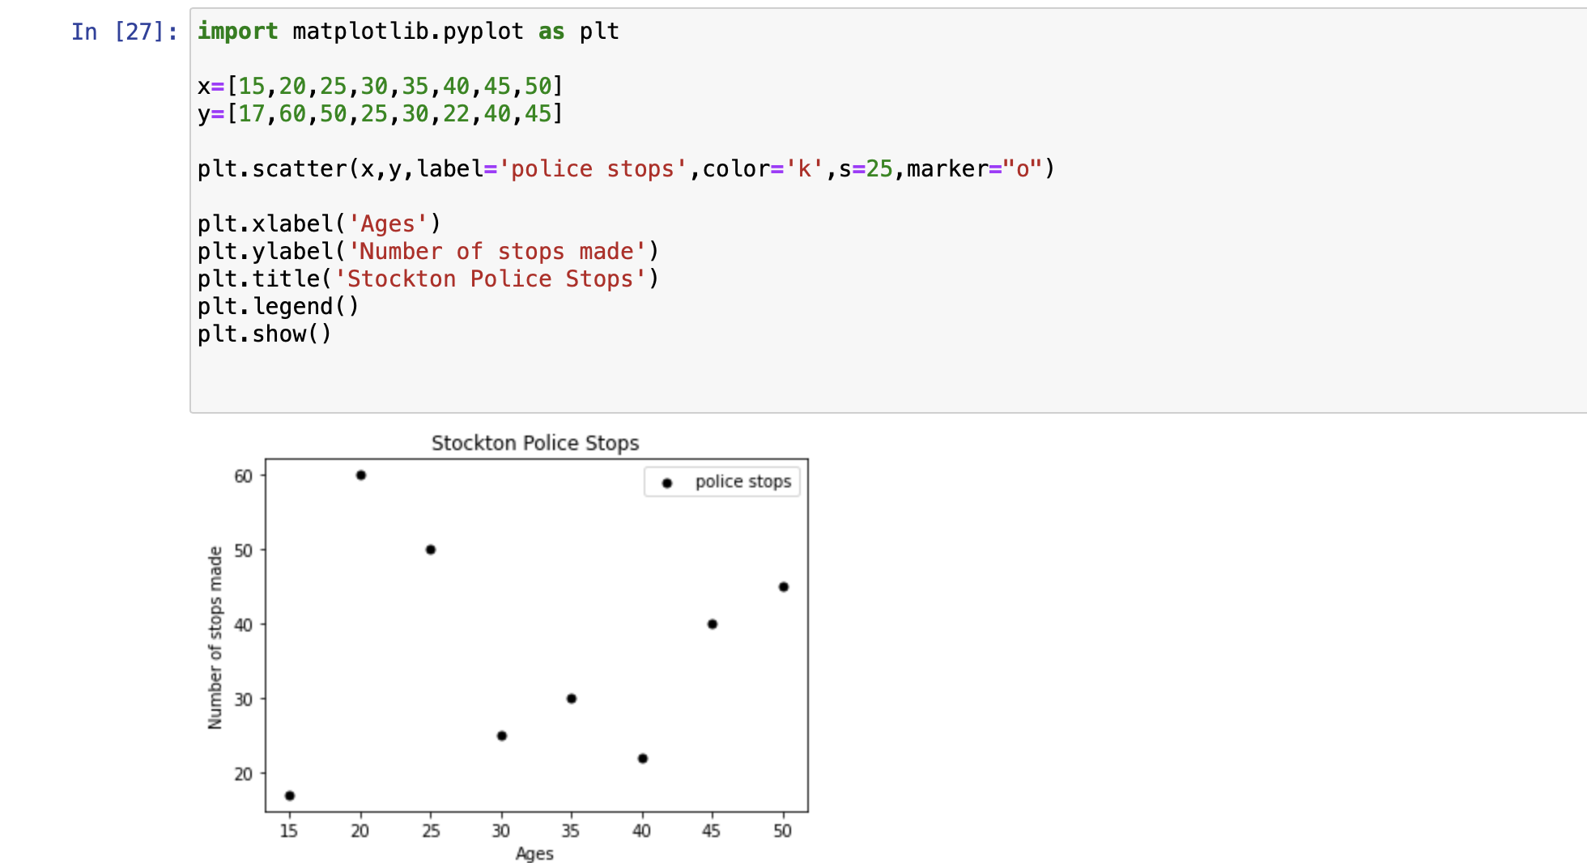

In the scatter plot the x axis shows the age and the y axis shows the number of stops. Each point shows the number of stops for each age with people at the age of 20 had the most stops.

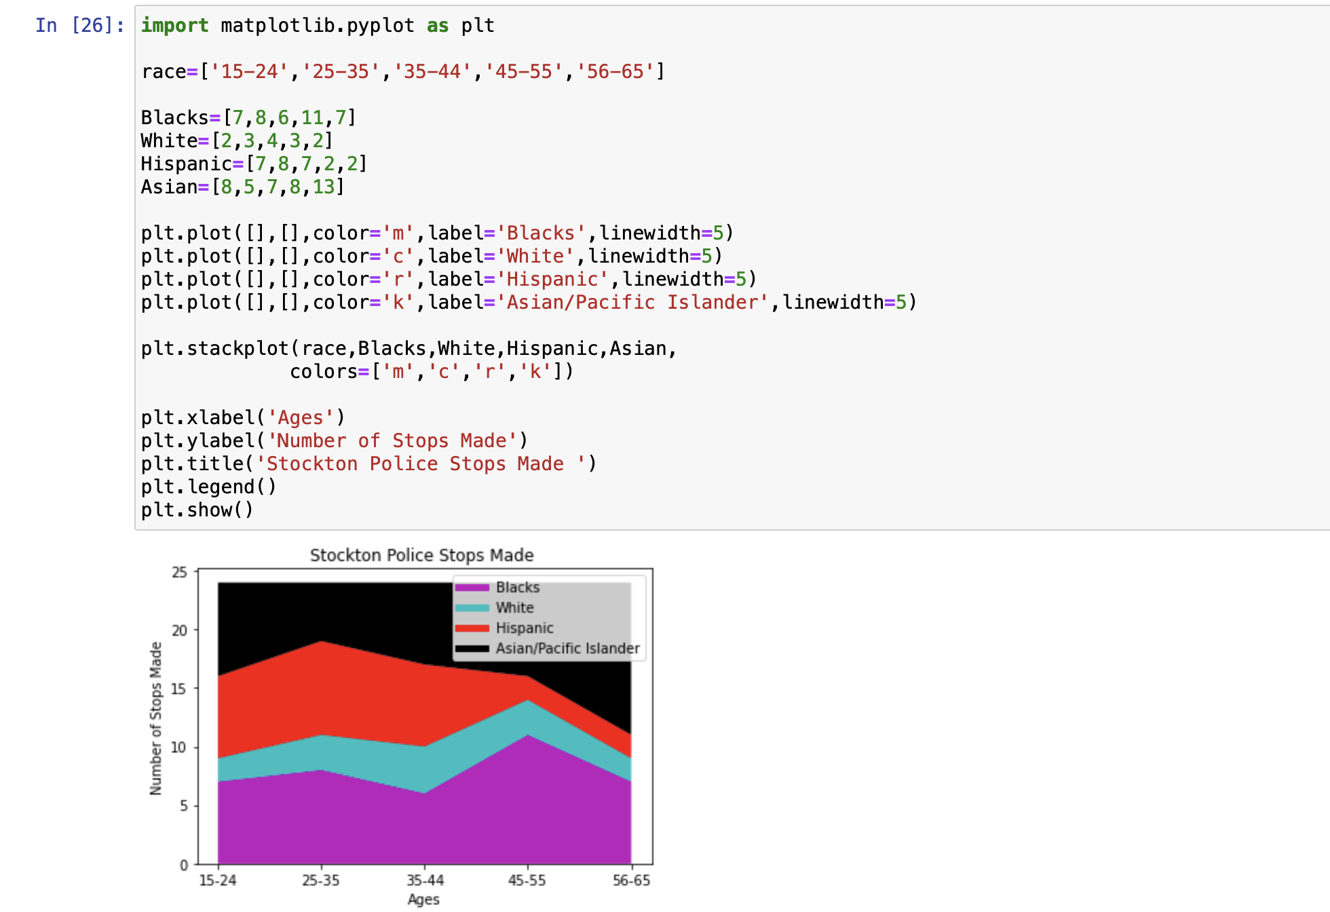

In the area plot the comparison of the ages and race are happening again with the age range as the x axis.

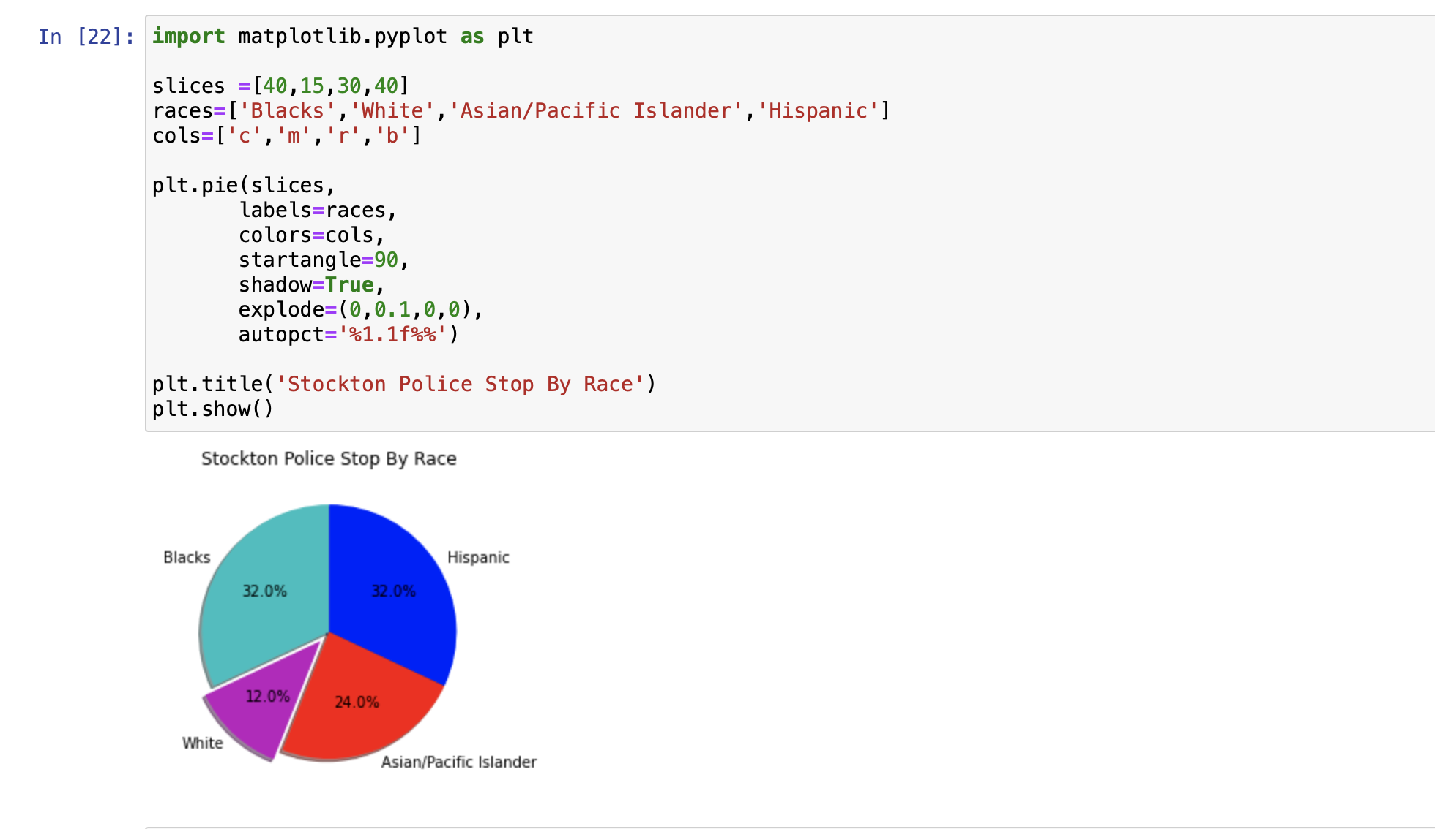

For this pie graph I compared the number of police stops for each race. As you can see African Americans and Hispanic make up for majority of the police stops with both races have 32% and White citizens having the least.

**Conclusion**

All in all, this course developed what we realized in CTEC 128. We utilized simply dominate and GUI instruments to outline information in CTEC 128. In CTEC 298 we customized utilizing Python and its libraries to plot outlines and diagrams. We learned python through Dataquest instructional exercises. We learned Matplotlib, NumPy, and Pandas through the different instructional exercises. Matplotlib, NumPy, and Pandas are useful assets for information science. Taking everything into account this class was an achievement in growing our insight about information science and its instruments.

**References**

* **Matplotlib**
* **GitHub**
* **City of Stockton, http://ww1.stocktonca.gov/Departments/Police.**
* **US Census Bureau. About the Survey. The United States Census Bureau. https://www.census.gov/programs-surveys/acs/about.html**